### Application to make the Gas filling Station easy using CRM ( admin )

By

Maddula Sanjay

(sanjaybhagavan03@gmail.com)

## 

## ABSTRACT:

The Gas Filling Store CRM Application is a comprehensive solution designed to streamline and simplify the gas filling process for both customers and store owners. By leveraging the power of customer relationship management (CRM), the application aims to enhance customer experiences, optimize store operations, and improve overall efficiency in the gas filling industry.

The application offers a range of features, including customer management, inventory management, sales and transactions, analytics and reporting, and employee management. Customer management features allow for the creation of detailed customer profiles, personalized communications, and effective loyalty programs. Inventory management tools enable real-time tracking of gas types and quantities, stock alerts, and supplier management. The sales and transactions module provides a user-friendly point-of-sale system, detailed sales reports, and flexible pricing management. Analytics and reporting features offer in-depth analysis of customer behavior, sales performance, and inventory trends, providing valuable insights for decision-making. Additionally, the application includes employee management tools for user roles and permissions, task management, and performance tracking.

By implementing this CRM solution, gas filling store owners can benefit from improved customer satisfaction, optimized operations, data-driven decision making, increased efficiency, and enhanced competitiveness. The application's user-friendly interface and powerful features make it a valuable tool for gas filling stores seeking to streamline their processes and improve their overall performance.

## 

## INDEX PAGE

#### Topics Page No.

Salesforce 4

Object 5-6

Tabs 7-8

The Lightning App 9

Fields 10-13

Page Layouts 14

Profiles 15-16

Role&Role Hierarchy 17

Users 18

Permisssion Sets 19

Setup for OWD 20

User Adoption 21

Reports 22

Dashboards 23

Flows 24

### SALESFORCE:

Creating a developer org in salesforce.   
1. Go to <https://developer.salesforce.com/signup>  
2. On the sign up form, enter the following details :

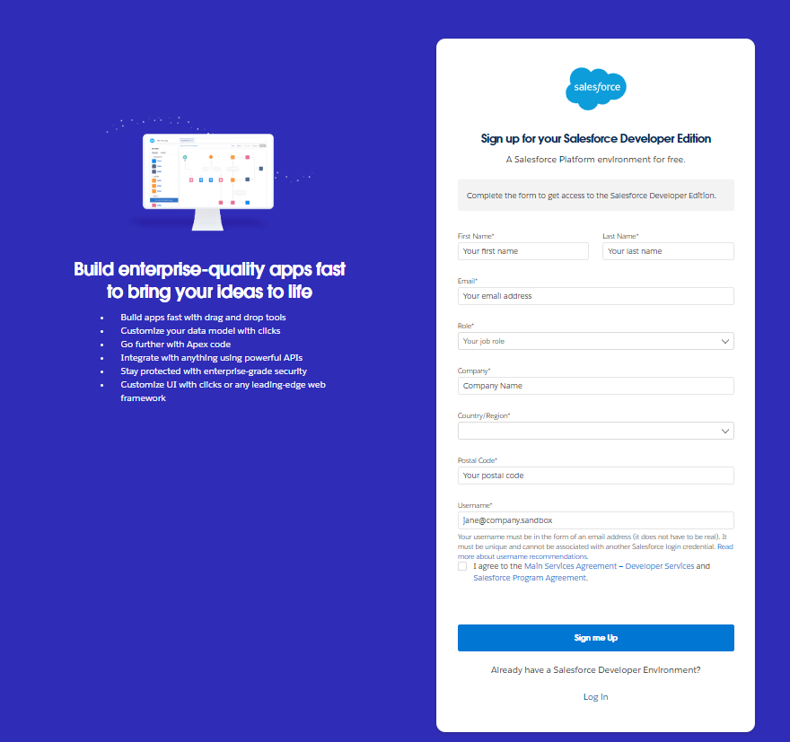

3.After verification through mail.

4.you will redirect to your salesforce setup page.

### 

### OBJECT:

#### Create Supplier Object

1. From the setup page ? Click on Object Manager ? Click on Create ? Click on Custom Object.
2. Enter the label name? Supplier
3. Plural label name? Suppliers
4. Enter Record Name Label and Format
5. Record Name ? Supplier Name
6. Data Type ? Name
7. Click on Allow reports and Track Field History,
8. Allow search ? Save.

***Create Gas Station Object***

1. To create an object:
2. From the setup page ? Click on Object Manager ? Click on Create ? Click on Custom Object.
3. Enter the label name? Gas Station
4. Plural label name? Gas Stations
5. Enter Record Name Label and Format
6. Record Name ? Gas Station
7. Data Type ? Auto Number
8. Display Format ? Gas-{000}
9. Starting number ? 1
10. Click on Allow reports and Track Field History,
11. Allow search ? Save.

***Create Buyer and Fuel Details Object***

1. Use these display format for the Buyer
2. label name ? Buyer
3. Plural label name ? Buyers
4. Display Format ? Buyer-{000}
5. Starting number ? 1
6. Use these display format for the Fuel details
7. label name ? Fuel details
8. Plural label name ? Fuel details

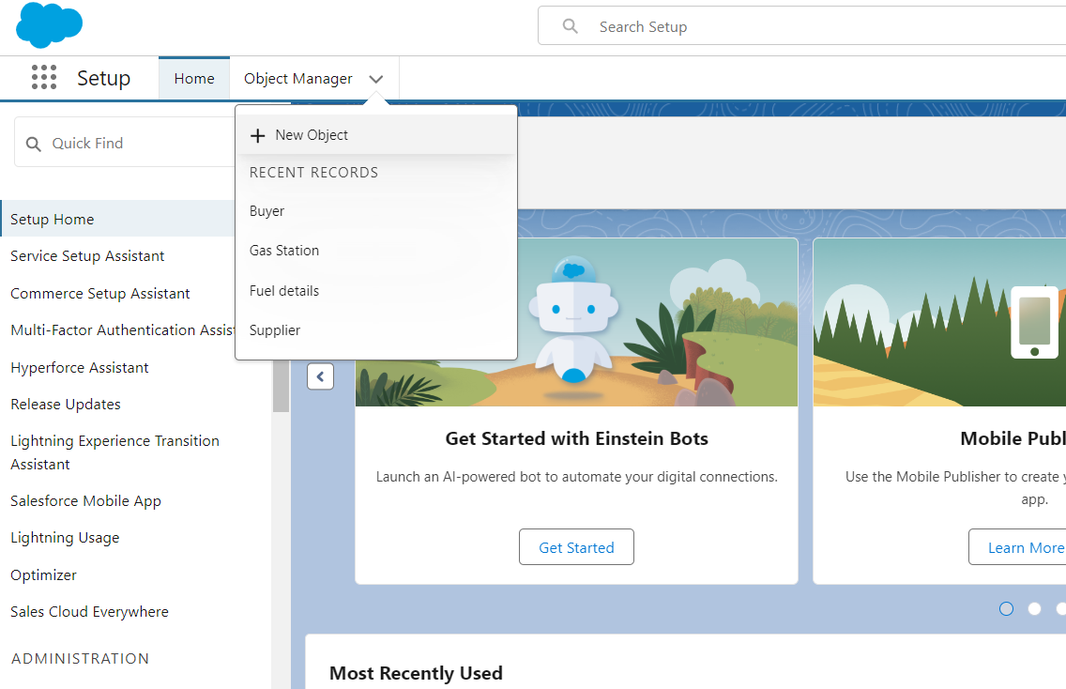

## 

## 

## TABS:

#### TYPES OF TABS

1.Custom Tabs

2.Web Tabs

3.Visual forcsTabs

4.Lightning Component Tabs

5.Lightning Page Tabs

### *Creating a Custom Tab*

1. Go to setup page ? type Tabs in Quick Find bar ? click on tabs ? New (under custom object tab)
2. Select Object(Supplier) ? Select the tab style ? Next (Add to profiles page) keep it as default ? Next (Add to Custom App) uncheck the include tab .
3. Make sure that Append tab to users' existing personal customizations is checked.
4. Click save.

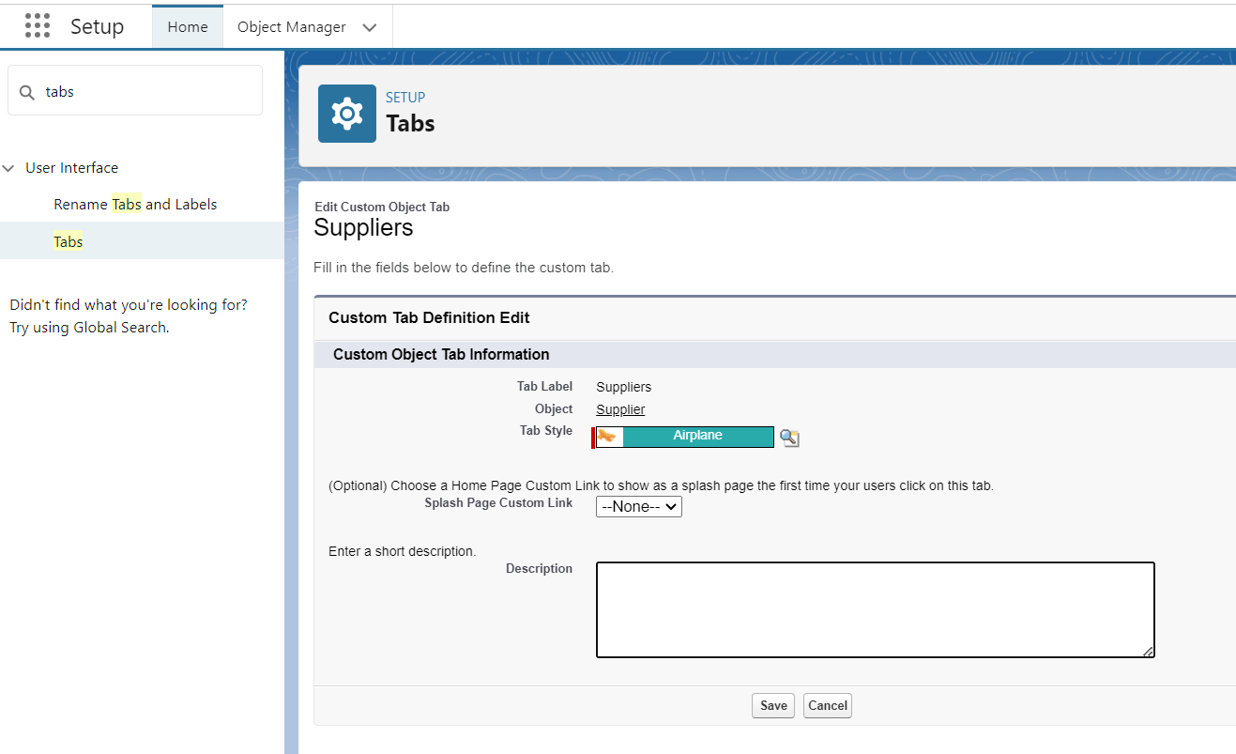

## 

## Creating Remaining Tabs

1. Now create the Tabs for the remaining Objects, they are “ Gas station, Buyer, Fuel details”.
2. By using the above same process create the reamaining tabs

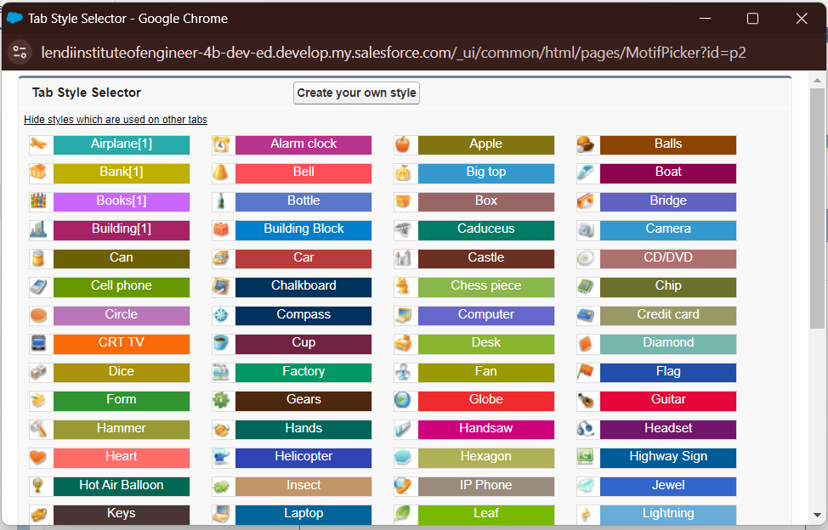

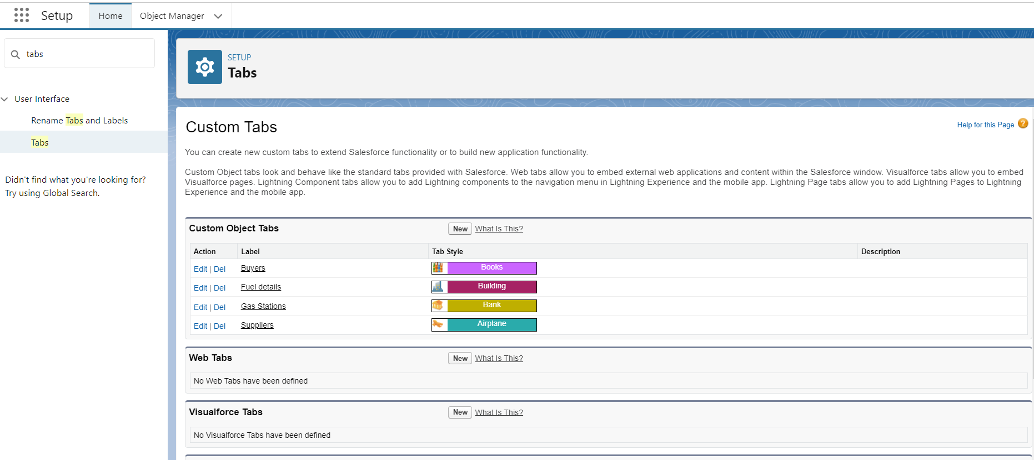

## The Lightning App:

### *Create a Lightning App*

1. Go to setup page ? search “app manager” in quick find ? select “app manager” ? click on New lightning App.
2. Fill the app name in app details as GAS STATION ?Next ? (App option page) keep it as default ? Next ? (Utility Items) keep it as default ? Nex
3. To Add Navigation Items:
4. To Add User Profiles:
5. Search profiles (System administrator) in the search bar ? click on the arrow button ? save & finish.

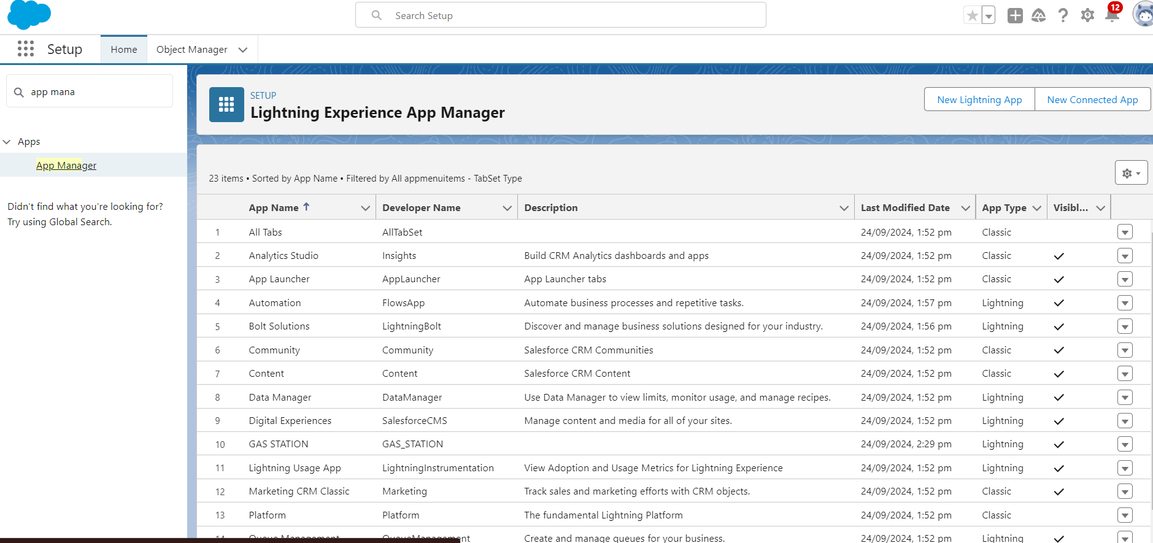

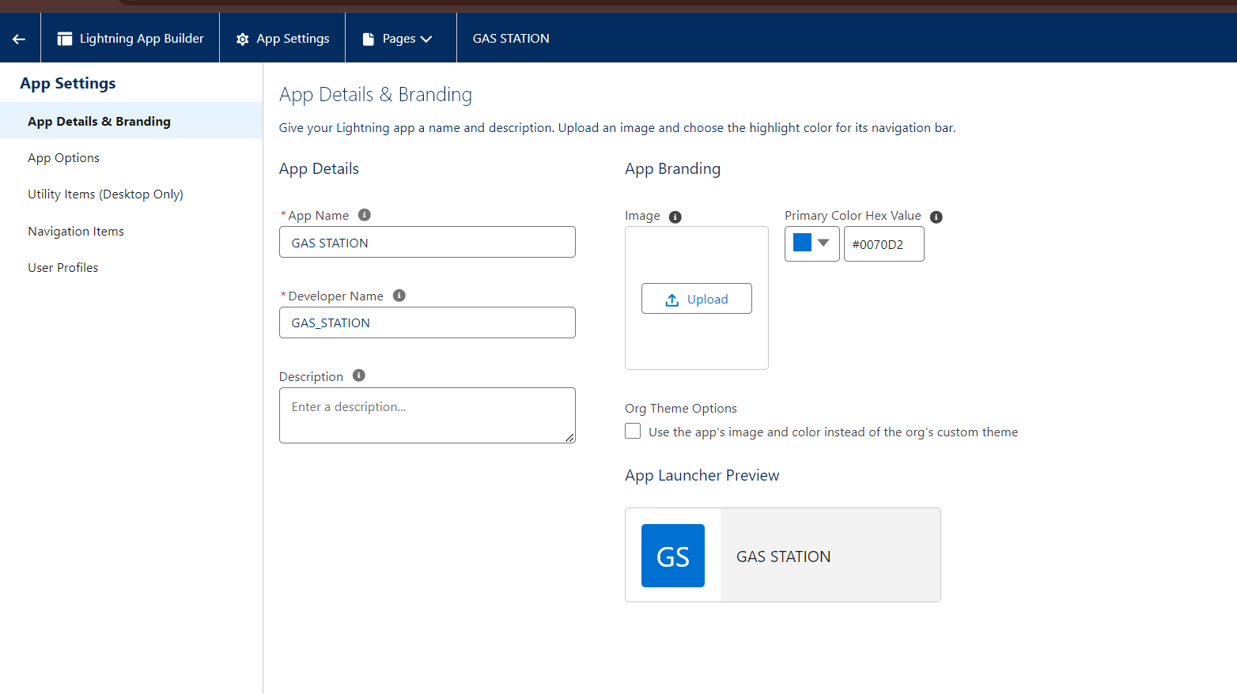

## FIELDS:

### Creating Junction Object

1. Go to the setup page ? click on object manager ? From drop down click edit for Fuel details object.
2. Click on fields & relationship ? click on New.
3. Select “Master-Detail relationship” as data type and click Next.
4. Select the related object “ Supplier ” and click next.
5. Give Field Label as “Supplier Name” and click Next.
6. Next ? Next ? Save & New.
7. Follow the same steps from 1 to 3.
8. Select the related object “ Gas station ” and click Next.
9. Give Field Label as “Gas Station” and click Next.
10. Next ? Next ? Save.

**Creating Master-Detail Relationship between Buyer & Gas Station Object**

To Create a Master-Detail relationship

1. Go to the setup page ? click on object manager ? From drop down click edit for Buyer object.
2. Click on fields & relationship ? click on New.
3. Select “Master-Detail relationship” as data type and click Next.
4. Select the related object “ Gas station ”.
5. Give Field Label as “Gas Station name” and click Next. Next,Next,Save.

## 

## 

## Creating the number field in Fuel details object

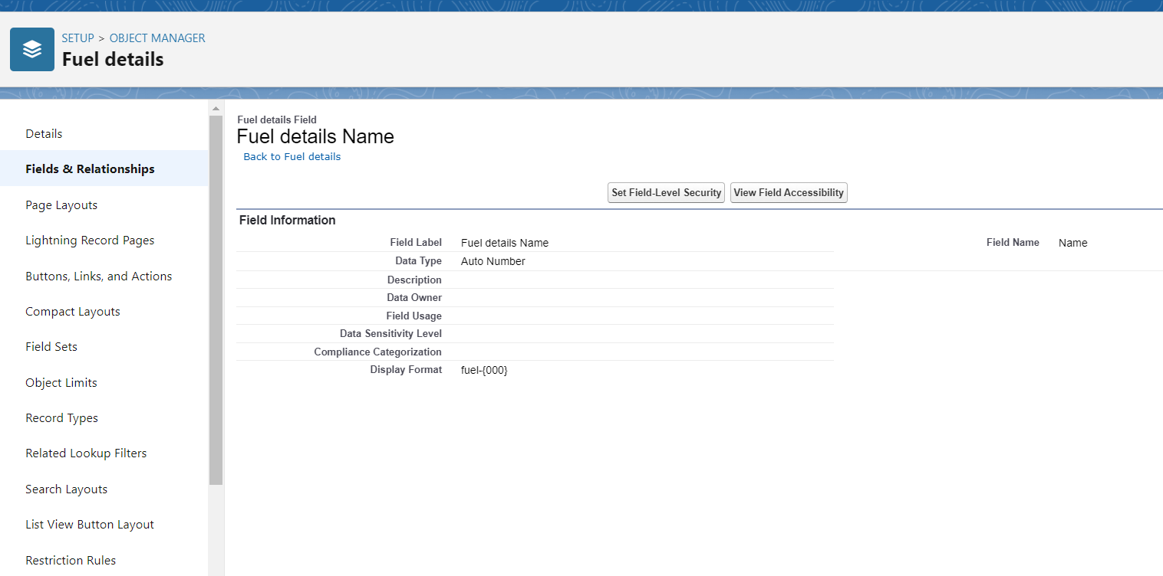

## Creating the Roll-up Summary

A rollup summary field is a field that summarizes data from a child object to a parent object that share a master-detail relationship. Rollup summary fields can use the COUNT, SUM, MIN, and MAX functions. For example, you could use a rollup summary field to display the total value (amount of fuel supplied ) from Fuel details on a related Supplier.

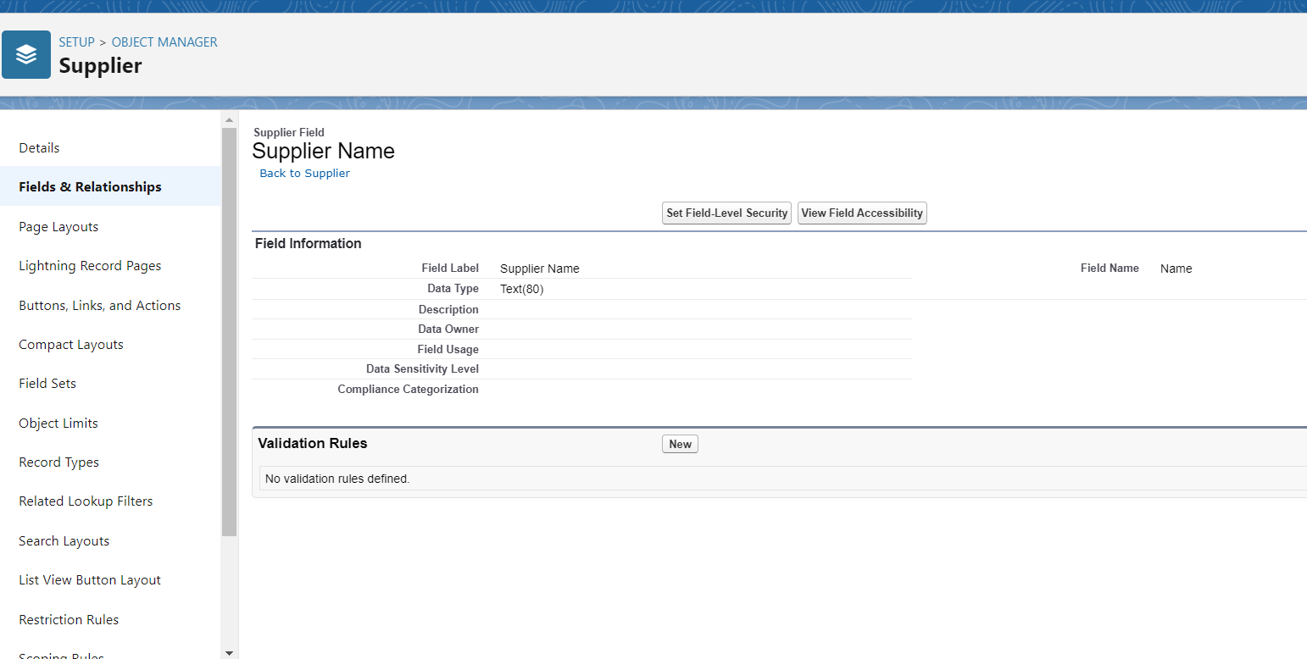

## Creating Formula Field in Gas Station Object

A formula field is a custom field that can be used to calculate or display data on a Salesforce record.

Formula fields can be used to perform a variety of tasks, such as:

* Calculating totals or averages
* Creating custom fields that display data from other fields
* Validating data entry
* Automating processes

### Creating Cross Object Formula Field in Buyer Object

A cross-object formula field is a formula field that references fields from another object in Salesforce. This type of formula allows users to calculate and display data from multiple objects on a single record.

#### Creating Picklist Field in Buyer Object

#### Creating the validation rule

#### Creating Remaining Fields in Objects:

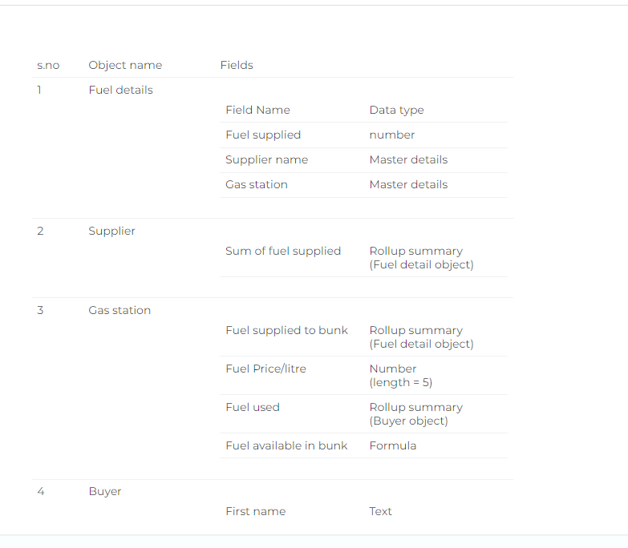

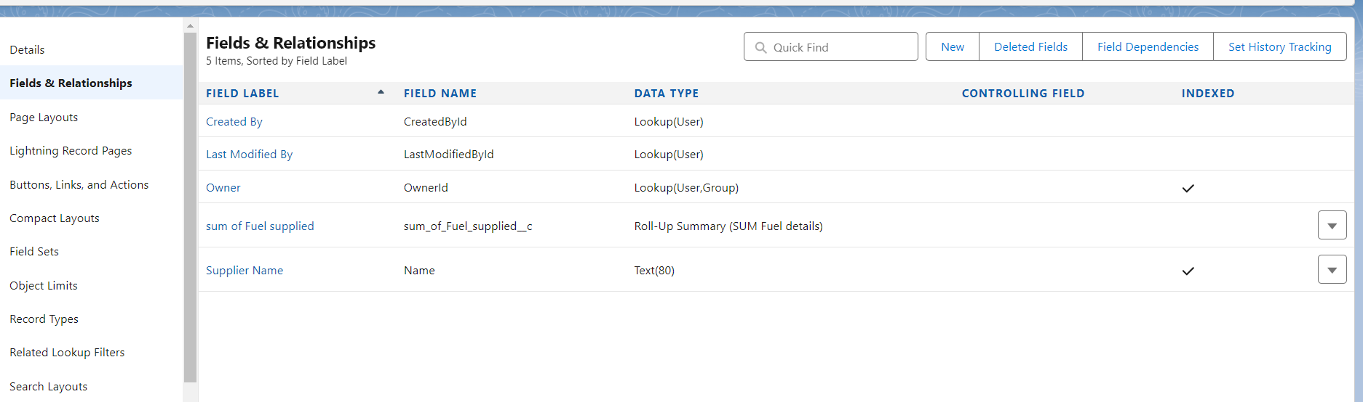

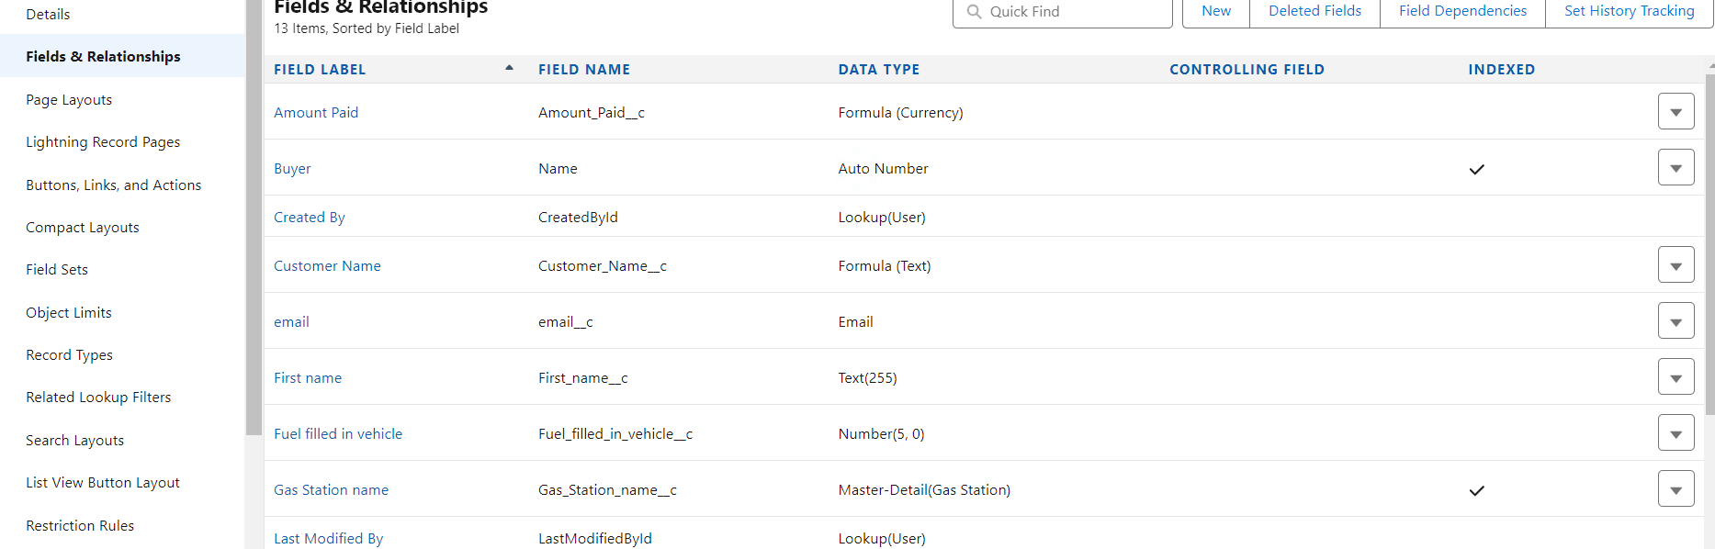

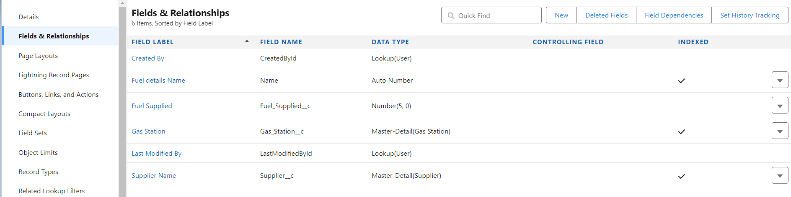

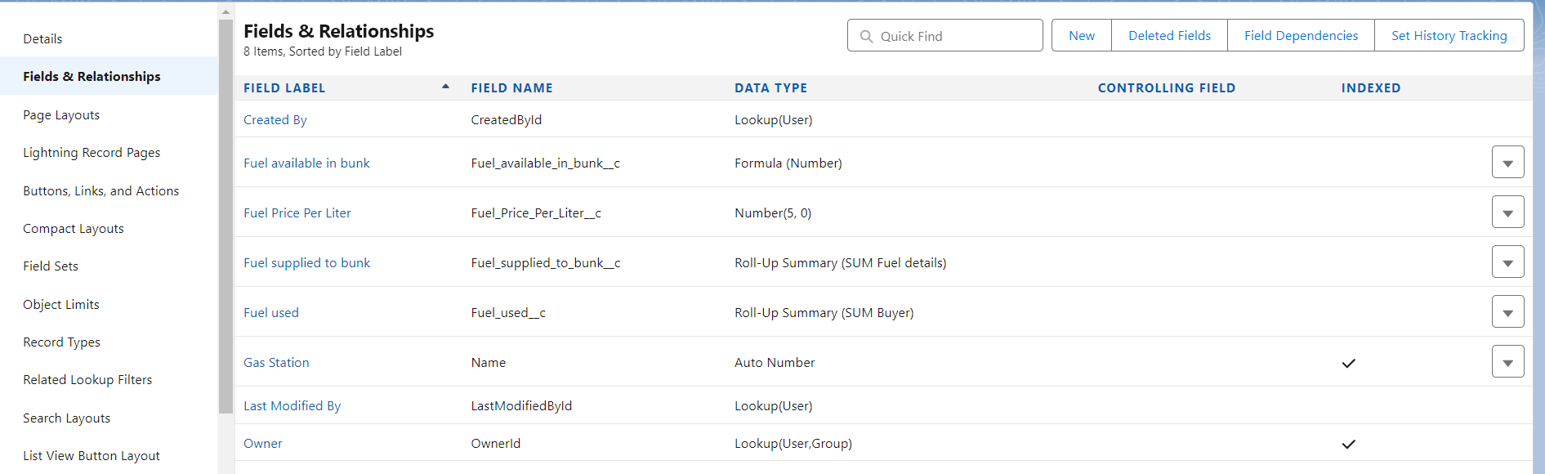

### Page layouts:

Page Layout in Salesforce allows us to customize the design and organize detail and edit pages of records in Salesforce. Page layouts can be used to control the appearance of fields, related lists, and custom links on standard and custom objects' detail and edit pages.

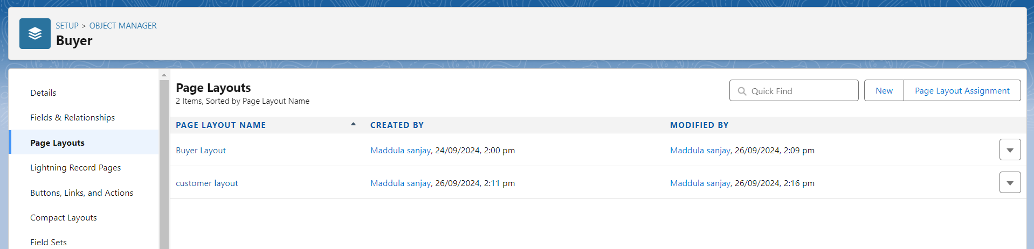

Go to Setup ? Click on Object Manager ? Search for the object (Buyer) ? From drop down select the object and click on it.

1. Click on Page layout ? Click on New
2. Select the existing page layout, and give the page layout name as “customer layout”, and click save.
3. Drag and drop the section field to Buyer details and create the section.
4. Enter the section name as “Persoanl details”, ? click Ok
5. Now drag the fields to this section that mentioned , they are

* First name , last name , customer name , phone number, email, Gas station name.

1. Follow the same process for another two sections as shown above , they are
2. One section is “ vehicle info ” , drag the fields that are

* Fuel filled in vehicle, vehicle type.

1. Another section is “Recepit details ”, and drag the fields that are

* Mode of payment , Amount paid.

1. Then , Click save.

## Profiles:

A profile is a group/collection of settings and permissions that define what a user can do in salesforce. Profile controls “Object permissions, Field permissions, User permissions, Tab settings, App settings, Apex class access, Visualforce page access, Page layouts, Record Types, Login hours & Login IP ranges. You can define profiles by the user's job function. For example System Administrator, Developer, Sales Representative.

Types of profiles in salesforce

1. Standard profiles:

By default salesforce provides below standard profiles.

* Contract Manager
* Read Only
* Marketing User
* Solutions Manager
* Standard User
* System Administrator.

We cannot deleted standard ones

Each of these standard ones includes a default set of permissions for all of the standard objects available on the platform.

1. Custom Profiles:

Custom ones defined by us.

They can be deleted if there are no users assigned with that particular one.

Create 3 profiles:

1.Manager profile

2.Sales Executive Profile

3.Sales Person Profile

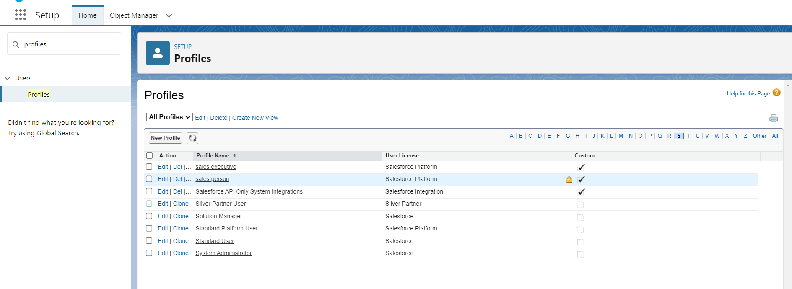

1. Go to setup ? type profiles in quick find box ? click on profiles ? clone the desired profile (Salesforce Platform User) ? enter profile name (sales executive) ? Save.
2. While still on the profile page, then click Edit.
3. Select the Custom App settings as default for the Gas station.
4. Scroll down to Custom Object Permissions and Give access permissions for Buyers, Fuel details , gas station and suppliers objects.
5. repeat the similar steps for manager and sales person

### Role & Role Hierarchy:

#### Creating Manager Role

1. Go to quick find ? Search for Roles ? click on set up roles.
2. Click on Expand All and click on add role under whom this role works.
3. Give Label as “Manager” and Role name gets auto populated. Then click on Save.

### Creating another roles

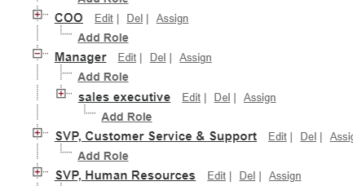

### Users:

### Create a User

1. Go to setup ? type users in quick find box ? select users ? click New user.
2. Fill in the fields
3. First Name : Niklaus
4. Last Name : Mikaelson
5. Alias : Give a Alias Name
6. Email id : Give your Personal Email id
7. Username : Username should be in this form: text@text.text
8. Nick Name : Give a Nickname
9. Role : Manager
10. User licence : Salesforce
11. Profiles : Manager

### Creating another users

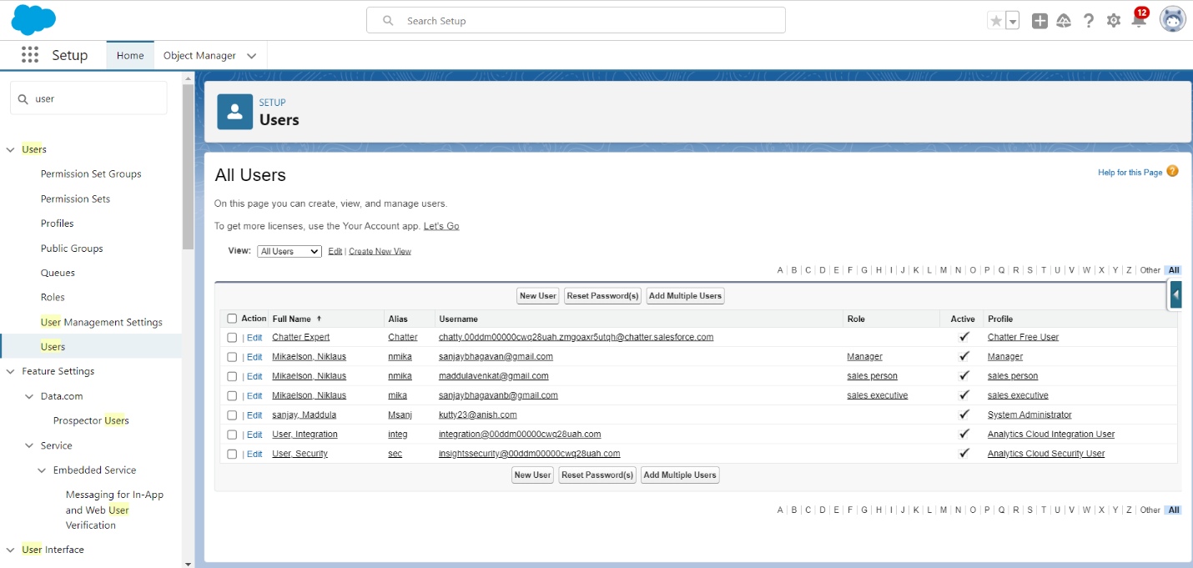

### Permission sets

A permission set is a collection of settings and permissions that give users access to various tools and functions. Permission sets extend users' functional access without changing their profiles. Users can have only one profile but, depending on the Salesforce edition, they can have multiple permission sets.

1.Go to setup ? type “permission sets” in quick search ? select permission sets ? New

1. Enter the label name as “P1”, API will be auto populated ? save.
2. Under Apps Select object settings.
3. Create on fuel details object?click on edit? under object permission check for read and create.
4. Click on Save.
5. After saving the permission click on the Manage assignment
6. Now click on the Add Assignment.
7. Now select the users which you have created in user milestone, using sales executive profile and click on Next ? Assign? Done.

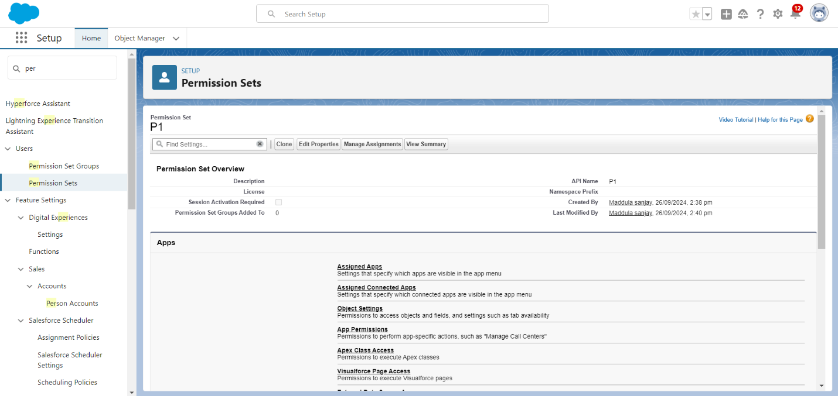

### Setup For OWD:

1. Go to setup ? type “sharing settings ” in quick search ? Click edit.  
    Scroll down, change the default internal access to “ public read-only” for Gas station and Supplier object.
2. Click save.
3. Extra information, By these every profile has their own access, according to their profile.
4. But in our case we created a roles and given the roles in such a way that manager can see sales executive and sales person records , sales executive can see the sales person records.

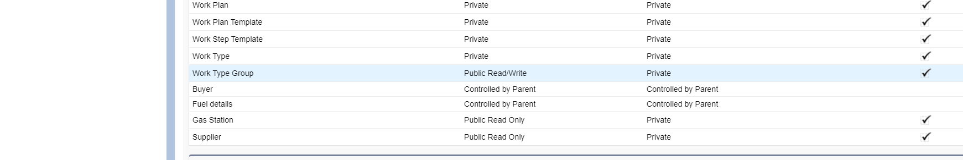

In Salesforce, OWD (Organization-Wide Defaults) defines the baseline level of access to data records for all users in an organization. OWD settings are used to determine the default sharing model for objects like accounts, contacts, and opportunities. There are three main OWD settings:

1. Private – Only the record owner and users above in the role hierarchy can access the record.
2. Public Read Only – All users can view records, but only the owner and those higher in the role hierarchy can edit them.
3. Public Read/Write – All users can view and edit records.

These settings can be further refined with role hierarchies, sharing rules, and manual sharing.

## User Adoption:

To create a record in junction object follow these steps

1. Click on the app launcher locate at left side of the screen.
2. Search for “ Gas station” and click on it.
3. Click on “ fuel details tab”
4. Creating the supplier record in fuel detail record, by clicking the “ new supplier ”
5. Creating the Gas station record in fuel details record, by clicking on new gas station.
6. Fill the remaining details

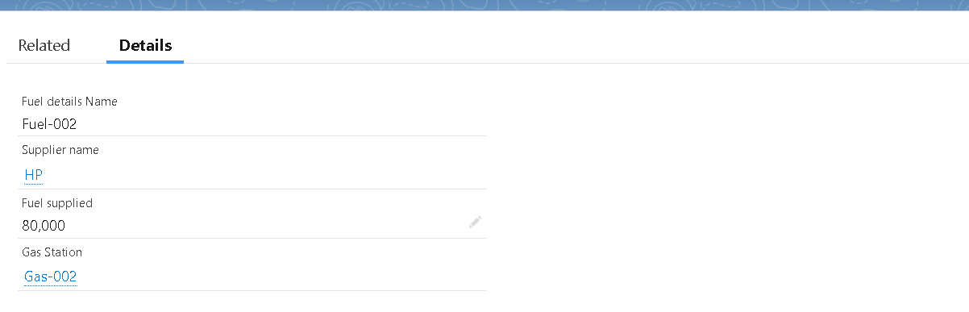

### Delete a record

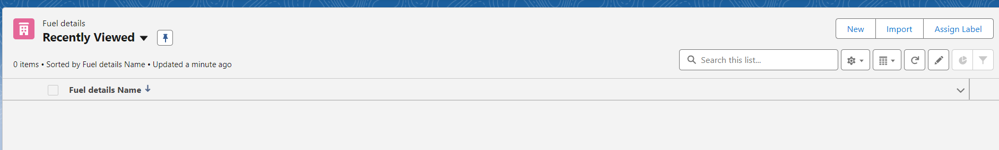

### Reports:

### create a report folder

1. Click on the app launcher and search for reports.
2. Double click on the report, “ reports tab” will be autopopulated in navigation bar.
3. Click on the report tab, click on new folder
4. Give the Folder label as “Fuel Estimation ”, Folder unique name will be auto populated.
5. Click save.

### Sharing a report folder

### Create Report

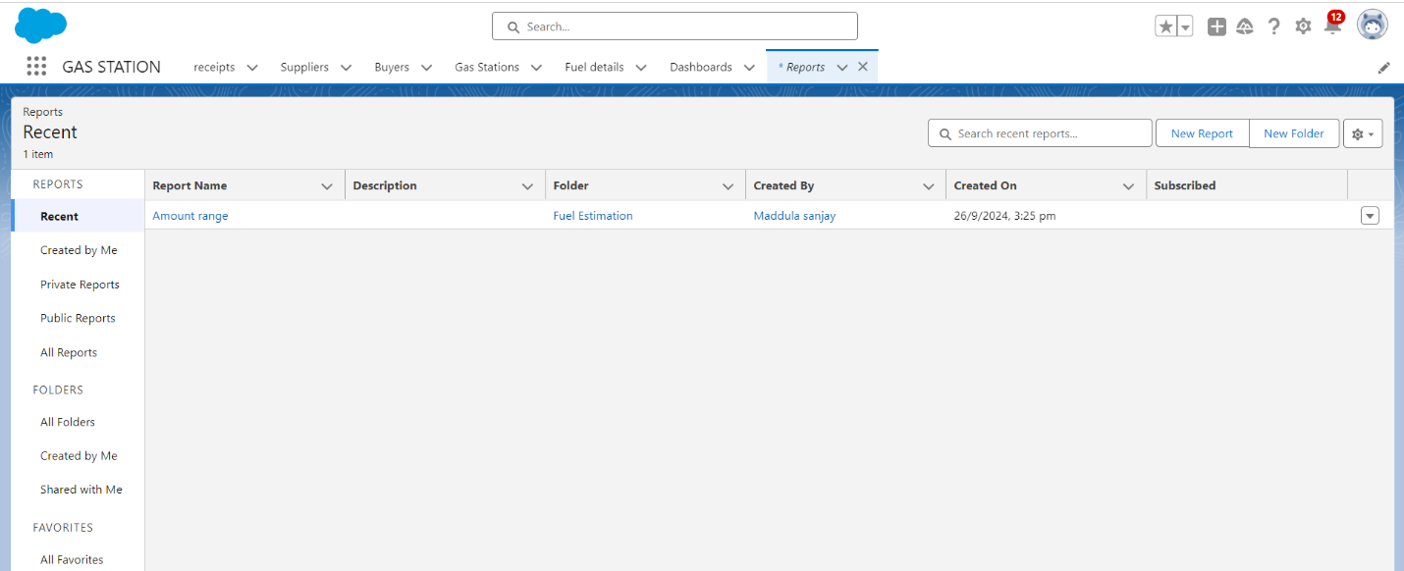

### 

### Dashboards

.Dashboards help you visually understand changing business conditions so you can make decisions based on the real-time data you’ve gathered with reports. Use dashboards to help users identify trends, sort out quantities, and measure the impact of their activities. Before building, reading, and sharing dashboards, review these dashboard basics.

### Create Dashboard Folder

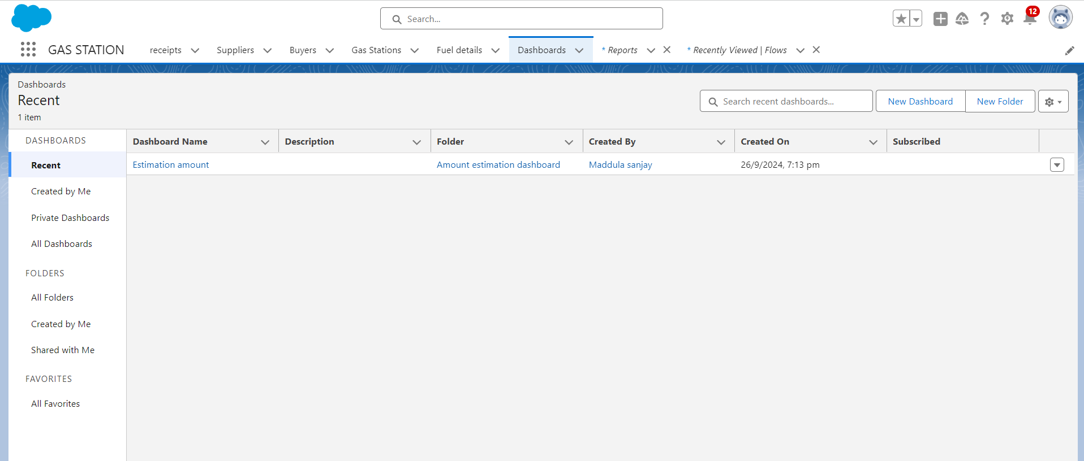

### Create Dashboard

1. Go to the app ? click on the Dashboards tabs
2. Give a Name and select the folder that created, and click on create
3. select add component.
4. Select a Report and click on select.
5. Click Add then click on Save and then click on Done.
6. Preview is shown below.

### Flows

In Salesforce, a flow is a powerful tool that allows you to automate business processes, collect and update data, and guide users through a series of screens or steps. Flows are built using a visual interface and can be created without any coding knowledge.

After forming a path Give the Flow label , Flow Api name will be autopopulated.

And click save, and click on activate

